**TEST SUMMARY REPORT**

for

ICTAK Alumni Job Portal

Group 2

**Prepared By:**

Anjana Baby

Akshay Mohan

Jeswin Sebastian

Maya M R

Pranav Vishnu

**Table of Contents**

| **Sl NO** | **TITLE** | **PAGE NO** |
| --- | --- | --- |
| 1. | PURPOSE | 3 |
| 2. | APPLICATION OVERVIEW | 3 |
| 3. | TESTING SCOPE | 3 |
| 1. In Scope | 3 |
| 1. Out of Scope | 3 |
| 1. Items not tested | 4 |
| 4. | TESTING METRICS | 4 |
| 5. | TYPES OF TESTING PERFORMED | 6 |
| 6. | TEST ENVIRONMENT AND TOOLS | 6 |
| 7. | RECOMMENDATIONS | 7 |
| 8. | DEFECT MATRIX | 7 |
| 9. | EXIT CRITERIA | 8 |
| 10. | CONCLUSION | 9 |

1. **PURPOSE**

This document explains the various activities performed as part of Testing of ICTAK Alumni Job Portal (<https://blush-harp-seal-hose.cyclic.app/>). This website provides different functionalities for users such as Admin, Employer, Faculty and Alumni.

1. **APPLICATION OVERVIEW**

**ICTAK Alumni Job Portal** is a website for the ICTAK Alumnis to register for different job openings posted on the site. Four types of users are allowed in the system called Admin, Employer, Faculty and Alumni. These four modules are integrated to fulfil the entire system functionalities. The system test of the ICTAK Alumni Job Portal website will include Sign Up and Login Modules for Alumni, Faculty, Employers, Admin. Admin can Add Alumni, Faculty and Employer and Create new post, View all posts, can approve requests from alumni and can approve jobs. The Employer can post job details, view and edit new job details and view resumes of approved posts. The faculty can view and create new posts. Students have to create a profile for themselves as Alumni.

1. **TESTING SCOPE**

**a) In Scope**

Functional Testing for the following modules are in Scope of Testing

1. Admin
2. Employer
3. Faculty
4. Alumni

**b) Out of Scope**

Database Testing

**c) Items not tested**

* + The logo, size and colour
  + Home button functionality in all pages
  + Admin dashboard
  + ‘View all post’ button in Admin Page
  + ‘View job’ button in employer dashboard
  + ‘Approved posts’ button in Employer dashboard
  + Search box and button for job posting in alumni home page
  + ‘View new post’ button in Faculty home page
  + Search box and button for job postings
  + Text present in admin dashboard
  + Footer contents like About, More and Quick links
  + All text present in Alumni home page.
  + All contents under ‘View New Post’ in the Faculty home page.
  + Delete, Edit, ReadMore, ViewResume buttons in Approve request from alumni page in Admin

1. **TESTING METRICS**

| **TEST SUMMARY REPORT - AUTOMATED** | | | |
| --- | --- | --- | --- |
|
| **SUMMARY ASSESSMENT** | **TOTAL NO. OF TEST CASES** | **% OF TOTAL PLANNED TEST CASES** | **COMMENTS** |
| Test cases Automated | 32 | 100 |  |
| Test cases Executed | 32 | 100 |  |
| Test cases Passed | 19 | 59 |  |
| Test cases failed | 13 | 41 | All bugs are reported |

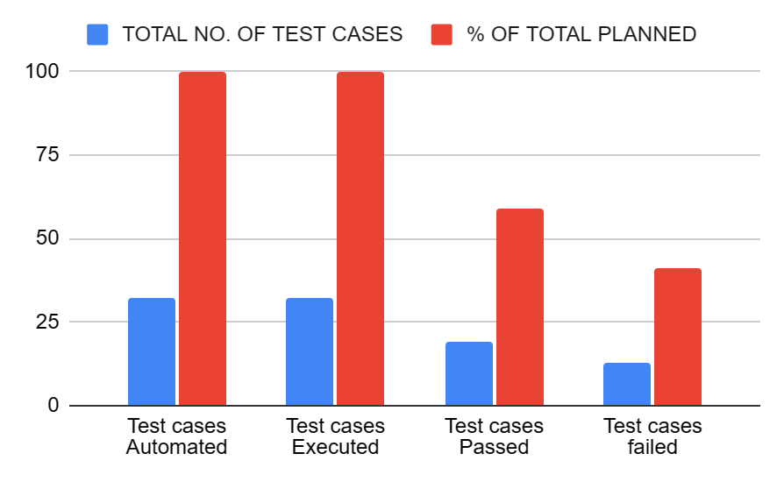

| **TEST SUMMARY REPORT - MANUAL** | | | |
| --- | --- | --- | --- |
|
| **SUMMARY ASSESSMENT** | **TOTAL NO. OF TEST CASES** | **% OF TOTAL PLANNED** | **COMMENTS** |
| Test cases Manual | 141 | 100 |  |
| Test cases Executed | 109 | 77.30496454 | Admin module not responding |
| Test cases Passed | 64 | 58.71559633 |  |
| Test cases failed | 45 | 31.91489362 |  |

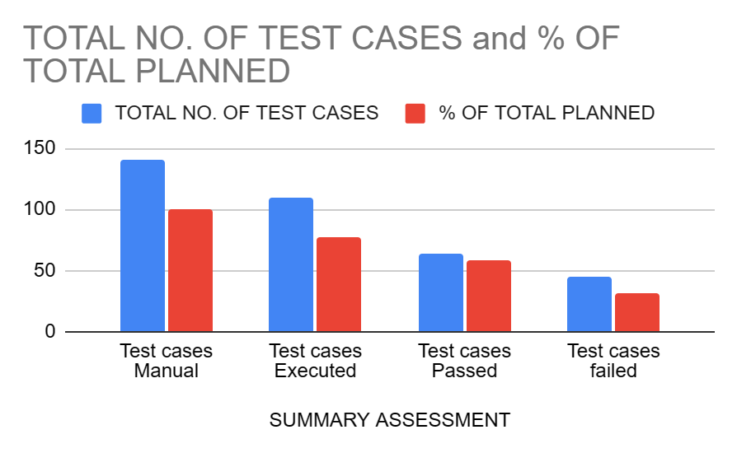

| **TEST CASES PLANNED** | **TEST CASES EXECUTED** | **TEST CASES PASSED** | **TEST CASES FAILED** |
| --- | --- | --- | --- |
| 141 | 109 | 64 | 45 |

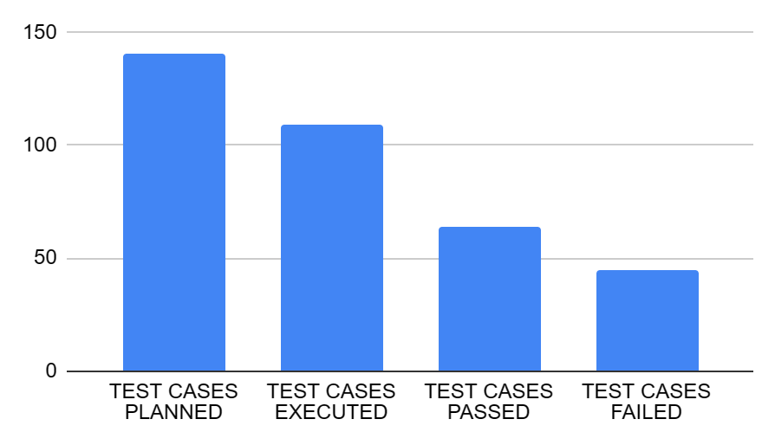

| **NUMBER OF DEFECTS IDENTIFIED** | | | | | |
| --- | --- | --- | --- | --- | --- |
|
|  | CRITICAL | HIGH | MEDIUM | LOW | TOTAL |
| OPEN | 4 | 31 | 9 | 3 | 47 |
| CLOSED | 0 | 0 | 0 | 0 | 0 |

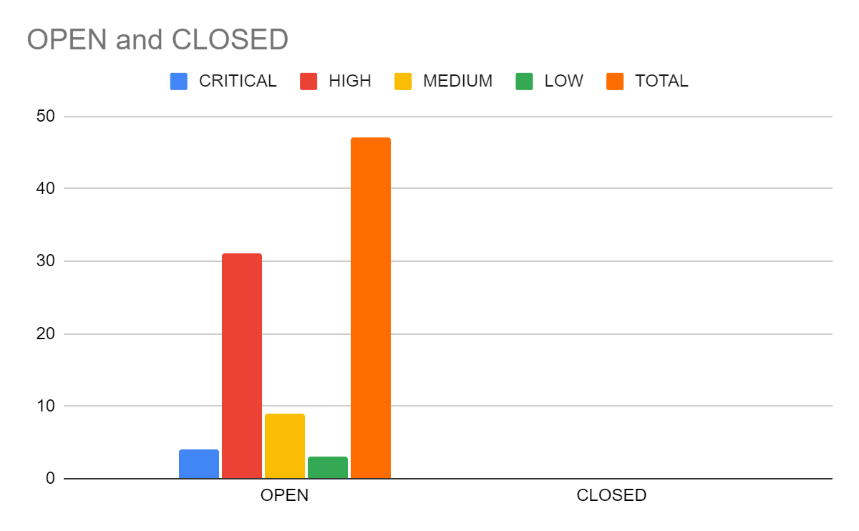

1. **TYPES OF TESTING PERFORMED**

* **System Testing**

System testing is testing conducted on a complete integrated system to evaluate the system's compliance with its specified requirements. System testing takes, as its input, all of the integrated components that have passed integration testing.

* **Integration Testing**

Integration testing is the phase in software testing in which individual software modules are combined and tested as a group. Integration testing is conducted to evaluate the compliance of a system or component with specified functional requirements. It occurs after unit testing and before system testing.

* **Acceptance Testing**

Acceptance testing is a test conducted to determine if the requirements of a specification or contract are met. It may involve chemical tests, physical tests, or performance tests.

1. **TEST ENVIRONMENT AND TOOLS**

* Operating System: Windows
* Browser: Google Chrome , Mozilla Firefox, Microsoft Edge
* Network: Wi-Fi
* Tools : JMeter, Eclipse IDE, Selenium, TestNG, Maven, Apache POI, Jira, Github, MSOffice

1. **RECOMMENDATIONS**

* It could be better to include Forgot Password link on the login pages.
* It could be better to support all browsers with the ‘Eye icon’, now only Edge supports the icon.
* It could be better to show the field required message on any missing field in the Employer post job detail.

### **DEFECT MATRIX**

| **Defect in phase** | **Critical** | **High** | **Medium** | **Low** | **Total** |
| --- | --- | --- | --- | --- | --- |
| Admin Signup | 1 |  |  |  | 1 |
| Admin Login | 1 |  |  |  | 1 |
| Admin Create Post | 1 |  |  |  | 1 |
| Approve request | 1 |  |  |  | 1 |
| Employer Signup |  |  | 2 |  | 2 |
| Employer Login |  |  | 2 |  | 2 |
| Faculty Signup |  | 1 |  | 3 | 4 |
| Faculty Login |  | 5 |  |  | 5 |
| Faculty Post Create |  | 1 |  |  | 1 |
| Alumni Signup |  | 23 |  |  | 23 |
| Alumni Login |  |  | 5 |  | 5 |
| Alumni Job Application |  | 1 |  |  | 1 |
| **Total** | **4** | **31** | **9** | **3** | **47** |

1. **EXIT CRITERIA**

| **Criteria** | **Yes/No** |
| --- | --- |
| All test cases should be executed | No |
| All defects in critical, High, Medium, low severity should be verified and closed | No |
| Testing is finished and there are no functional bugs | No |
| All the remaining bugs have low severity | No |
| No more than 10% of medium-severity bugs are open | No |

1. **CONCLUSION**

None of the Exit Criteria mentioned in section 9 were met. Critical bugs in the admin module are still open, also some high,medium and low priority bugs in other modules are open as mentioned in section 8. So forwarding to the development team to fix all the bugs.